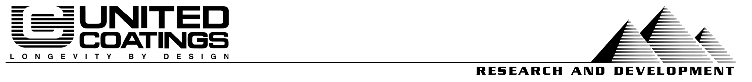
6/4/04

File #: CS 0757B
Project & Purpose:
Evaluation of Uniflex 255 by test methods that might be useful specifying and promotions of the value that these products give.
Products:
Uniflex 255 Pt A White #96834
Uniflex 255 Pt B #97231
TT-P-19D Control (Century 2000 White #97366)
Procedures:
D4060 Standard Test Method for Abrasion Resistance of Organic Coatings by the Taber Abraser
E303 Standard Test Method for Measuring Surface Frictional Properties Using the British Pendulum Tester
Ford Motor Company Method BN-108-02
Key Results:
— Friction and Abrasion Results Vs. Paint—
Test Methods →  Products↓ | Taber Abrasion  ASTM D4060 |  | Ford Scuffing Test BN-108-02 | Dynamic Friction ASTM E303
Test Methods →  Products↓ | Taber CS-17 Wheel | S-39 (Shoe Leather) | Type “B” severe | British Pendulum
Uniflex 255 | 0.077 gram wt. loss | 0.000 gram wt. loss | 0.011 gram wt. loss | 73.5
Rhino Top textured | 0.075 gram wt. loss | 0.000 gram wt. loss | 0.014 gram wt. loss | 63.3
TT-P-19D paint | 0.263 gram wt. loss | 0.000 gram wt. loss | 0.008 gram wt. loss | 50
Conclusion:
Uni-Flex 255 possesses an effective combination of anti-slip and abrasion resistant properties, even when compared to UNITED’S specialialty water-based textured deck paint. Uniflex 255 provides close to 50% more grip (British Pendulum) than a flat paint and approximately 16% more grip than our water-based offset. The BP test is based on the correct assumption that people and wheels are moving objects, and that slippage is most often an undesirable characteristic.

In the case of light abrasives, such as urban and residential soils (CS-17 wheel/Taber), Uniflex 255 provides over three times the abrasion resistance of standard acrylic latex paint. It is also exceptionally resistant to wear from shoe leather. Uniflex 255 is also more scuff resistant than UNITED’S textured deck paint, as measured by an automotive seat cover test (Ford type B). This test reflects on the coatings ability to handle furniture and other sharp metal edges that may be encountered in this kind of service. This results confirm the advantage of the urethane chemistry utilized in Uni-Flex 255, which provides superior grip in addition to increased scuff resistance and other forms of abrasion resistance. It does this while also being exceptionally UV stable and permanently flexible.

Prepared by:
Steve Heinje | Patty White
VP Research | Compounder

